# **CAR GAME**

Using

# LCD Interfacing with External Interrupt

# By:

# B.Prashanth Yadav (20134164)

# B.Yaswanth (20134150)

# Group: CS-A1

# Abstract

This project “*Car game on LCD Display*” is a game which is controlled with two buttons. One button is to start the game. There is a *car(X)* present at the left corner of the 16x2 LCD display. It can be moved up and down using the second button. A series of *obstacles(0)* and *points(1)* arrives the car starting from the right corner of the display. The player has to collect the points and escape the obstacles by moving the car up and down. For each point collected by the player, his score gets incremented by 1. The game ends when the player touches any obstacle and total score is displayed on the screen.

# Technical Details

Circuit Components:

1. Atmega32 Micro-controller
2. 16x2 LCD Display
3. Buttons (2)
4. Bread board

Block Diagram:

LCD Display

Micro

Controller

Start Button

Move Button

Power Supply (+5V)

Circuit Diagram: ­­

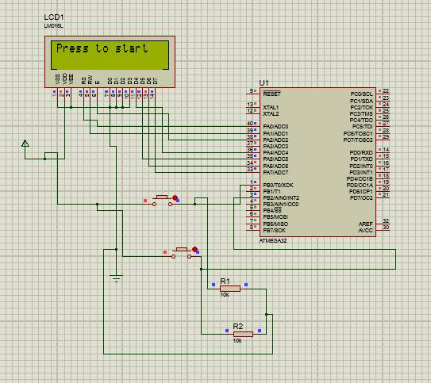

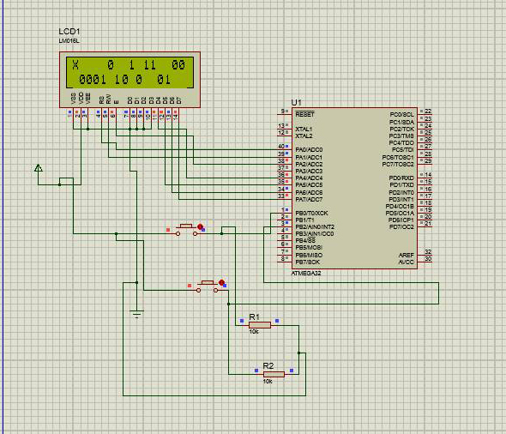

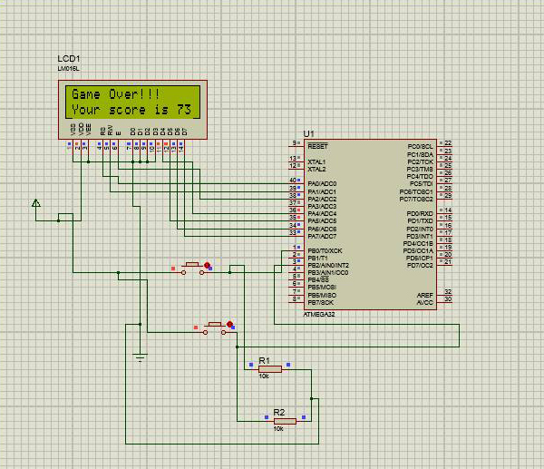

Pin Configurations:

Atmega32:

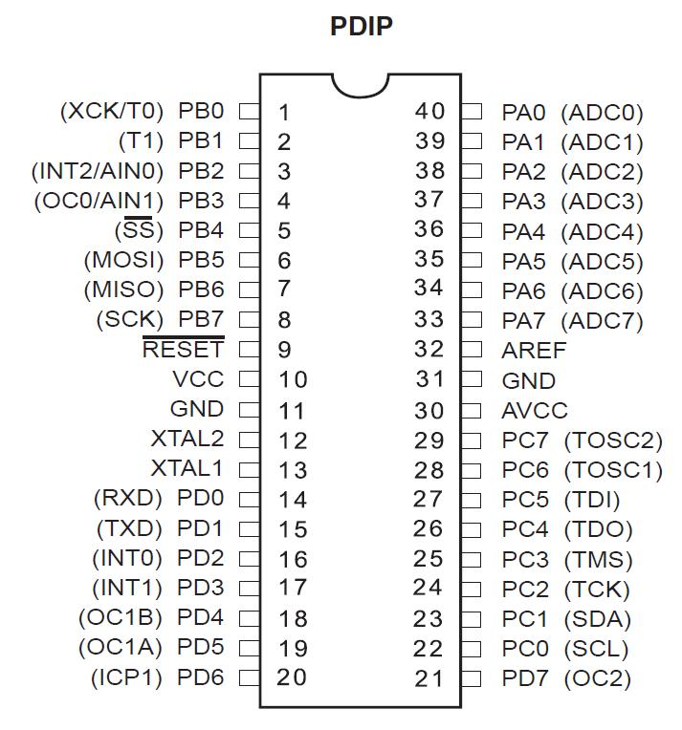

LCD Display:

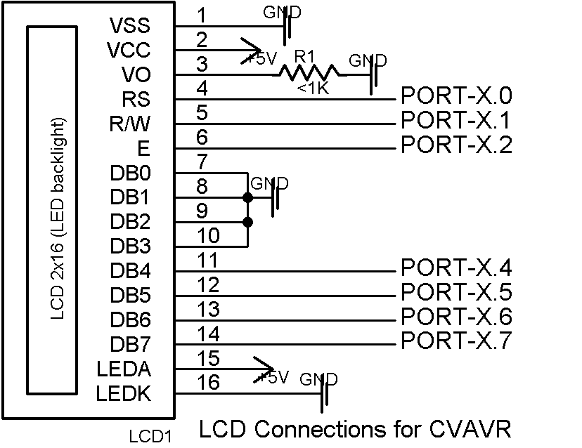

Description:

The whole setup consists of a micro controller, LCD Display and two buttons to operate. Let us discuss the pin diagrams of these components.

**PIN Configuration:**

Atmega32 has 40 pins, which are divided into 4 ports i.e, PORTA, PORTB, PORTC, PORTD and some other pins including RESET, GND, VCC, AVCC. We discuss only the pins required for this project. Each PORTX has 8 pins from PORTX.0 to PORTX.7. These ports are used as I/O ports. There are also several other functions of those ports but are not required in the case of LCD Interfacing.

16x2 LCD display has 16 pins where 8 of them are PORTX’s and the rest are either GND or VCC.

Each button is connected to a VCC and GND along with a 10K resistor.

**Procedure:**

* We select any port, let us say PORTA. The PORTA.y of Atmega32 are connected to PORTX.y of LCD respectively.
* And all connections of GND and VCC are made according to the PIN diagram for both Atmega32, LCD display and buttons.
* Now the functionalities should be fed into the micro controller. For this we use “*CVAVR”.* It provides a GUI to describe the PIN behaviour of all the components and allows us to write the functionality code in high level languages like C, Java etc.
* This code is to be converted to machine code to be understood by the Micro controller.
* This also can be done by CVAVR . It converts our “.c” file into “.hex” file, which can be fed into micro controller.
* To make a connection between your computer and micro controller we need a device called Programmer.
* The GND and VCC can also be provided by Programmer or if already the program is fed into the controller, we can supply power using an adapter.
* The connections are successfully completed now, and the game can be played.

**How to play:**

* Now after providing the power, the LCD glows with the Start screen. Press start button to start the game. Then the player can be moved using the other button.
* The other button to move is the Interrupt button. It sends interrupt to the process printing the 0, 1 array to the screen and moves the player, then the first process continues.
* When the player collides with an Obstacle represented by 0, the game is over and if he gets collided with 1, he gets a point.
* The code representing the game is below.

Code:

/*****************************************************

This program was produced by the

CodeWizardAVR V2.05.0 Professional

Automatic Program Generator

© Copyright 1998-2010 Pavel Haiduc, HP InfoTech s.r.l.

http://www.hpinfotech.com

Project : Car game with lcd display

Version :

Date : 01-11-2015

Author : B.Prashanth (20134164) and B.Yaswanth (20134150)

Company :

Comments:

Chip type : ATmega32

Program type : Application

AVR Core Clock frequency: 8.000000 MHz

Memory model : Small

External RAM size : 0

Data Stack size : 512

*****************************************************/

#include <mega32.h>

#include <delay.h>

#include <stdlib.h>

// Alphanumeric LCD Module functions

#include <alcd.h>

int s,a[16][2],y,i,j,z,counter,score,speed=150;

char c[10];

void main(void);

// External Interrupt 1 service routine

interrupt [EXT_INT1] void ext_int1_isr(void)

{

// Place your code here

}

// External Interrupt 2 service routine

interrupt [EXT_INT2] void ext_int2_isr(void)

{

s++;

delay_ms(100);

if(s==2)

s=0;

}

// Declare your global variables here

void init()

{

for(i=1;i<16;i++)

for(j=0;j<=1;j++)

a[i][j]=0;

s=y=i=j=z=counter=score=0;

speed=150;

}

void player(void)

{

lcd_gotoxy(0,s);

lcd_putchar('X');

lcd_gotoxy(0,1-s);

lcd_putchar(' ');

}

void finish()

{

lcd_clear();

lcd_puts("Game Over!!!");

lcd_gotoxy(0,1);

itoa(score,c);

lcd_puts("Your score is ");

lcd_puts(c);

while(1)

{

if(PINB.0==1)

{

delay_ms(1000);

init();

main();

}

}

}

// Declare your global variables here

void obstacle(void)

{

if(a[1][s]==1)

{

finish();

}

if(a[1][1-s]==2)

{

finish();

}

if((a[1][0]==2) || (a[1][1]==2)){

score++;

if(score>1)

if(score%2==0)

speed--;

}

z++;

z=(z+rand()%2)%2;

y=(rand()+z)%4;

if(y==1)

{

a[15][z]=1;

a[15][1-z]=0;

}

if(y==0)

{

a[15][z]=0;

a[15][1-z]=1;

}

if(y==3)

{

a[15][z]=0;

a[15][1-z]=2;

}

if(y==2)

{

a[15][z]=2;

a[15][1-z]=0;

}

for(i=1;i<15;i++)

{

a[i][0]=a[i+1][0];

a[i][1]=a[i+1][1];

}

}

void print(void)

{

for(i=15;i>=1;i--){

for(j=0;j<2;j++){

lcd_gotoxy(i,j);

if(a[i][j]==1){

lcd_putchar('0');

}

else if(a[i][j]==2)

lcd_putchar('1');

else

lcd_putchar(' ');

}

}

}

void main(void)

{

// Declare your local variables here

// Input/Output Ports initialization

// Port A initialization

// Func7=In Func6=In Func5=In Func4=In Func3=In Func2=In Func1=In Func0=In

// State7=T State6=T State5=T State4=T State3=T State2=T State1=T State0=T

PORTA=0x00;

DDRA=0x00;

// Port B initialization

// Func7=In Func6=In Func5=In Func4=In Func3=In Func2=In Func1=In Func0=In

// State7=T State6=T State5=T State4=T State3=T State2=T State1=T State0=T

PORTB=0x00;

DDRB=0x00;

// Port C initialization

// Func7=In Func6=In Func5=In Func4=In Func3=In Func2=In Func1=In Func0=In

// State7=T State6=T State5=T State4=T State3=T State2=T State1=T State0=T

PORTC=0x00;

DDRC=0x00;

// Port D initialization

// Func7=In Func6=In Func5=In Func4=In Func3=In Func2=In Func1=In Func0=In

// State7=T State6=T State5=T State4=T State3=T State2=T State1=T State0=T

PORTD=0x00;

DDRD=0x00;

// Timer/Counter 0 initialization

// Clock source: System Clock

// Clock value: Timer 0 Stopped

// Mode: Normal top=0xFF

// OC0 output: Disconnected

TCCR0=0x00;

TCNT0=0x00;

OCR0=0x00;

// Timer/Counter 1 initialization

// Clock source: System Clock

// Clock value: Timer1 Stopped

// Mode: Normal top=0xFFFF

// OC1A output: Discon.

// OC1B output: Discon.

// Noise Canceler: Off

// Input Capture on Falling Edge

// Timer1 Overflow Interrupt: Off

// Input Capture Interrupt: Off

// Compare A Match Interrupt: Off

// Compare B Match Interrupt: Off

TCCR1A=0x00;

TCCR1B=0x00;

TCNT1H=0x00;

TCNT1L=0x00;

ICR1H=0x00;

ICR1L=0x00;

OCR1AH=0x00;

OCR1AL=0x00;

OCR1BH=0x00;

OCR1BL=0x00;

// Timer/Counter 2 initialization

// Clock source: System Clock

// Clock value: Timer2 Stopped

// Mode: Normal top=0xFF

// OC2 output: Disconnected

ASSR=0x00;

TCCR2=0x00;

TCNT2=0x00;

OCR2=0x00;

// External Interrupt(s) initialization

// INT0: Off

// INT1: On

// INT1 Mode: Falling Edge

// INT2: On

// INT2 Mode: Rising Edge

GICR|=0xA0;

MCUCR=0x08;

MCUCSR=0x40;

GIFR=0xA0;

// Timer(s)/Counter(s) Interrupt(s) initialization

TIMSK=0x00;

// USART initialization

// USART disabled

UCSRB=0x00;

// Analog Comparator initialization

// Analog Comparator: Off

// Analog Comparator Input Capture by Timer/Counter 1: Off

ACSR=0x80;

SFIOR=0x00;

// ADC initialization

// ADC disabled

ADCSRA=0x00;

// SPI initialization

// SPI disabled

SPCR=0x00;

// TWI initialization

// TWI disabled

TWCR=0x00;

// Alphanumeric LCD initialization

// Connections specified in the

// Project|Configure|C Compiler|Libraries|Alphanumeric LCD menu:

// RS - PORTA Bit 0

// RD - PORTA Bit 1

// EN - PORTA Bit 2

// D4 - PORTA Bit 4

// D5 - PORTA Bit 5

// D6 - PORTA Bit 6

// D7 - PORTA Bit 7

// Characters/line: 8

lcd_init(16);

// Global enable interrupts

#asm("sei")

lcd_puts("Press to start");

while (1)

{

if(PINB.0==1)

{

delay_ms(50);

while (1)

{

counter++;

print();

player();

if(counter%speed==0)

{

obstacle();

counter=0;

}

}

}

}

}

­­­­